**Introduction to Treble :**

A new element in the Android 8.0 release is Project Treble. This is a major architectural change in the Android operating system framework designed to make it easier and faster for manufacturers to update devices to the new Android system at a lower cost. Project Treble is available for all new devices with Android 8.0 and later .

Android 8.0 re-architected the Android OS framework (in a project known as Treble) to make it easier, faster, and less costly for manufacturers to update devices to a new version of Android.

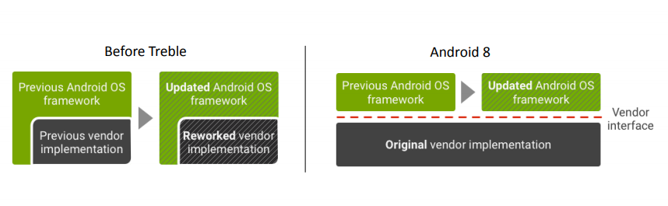

**Android classic architecture :**

Android System Services and everything above is “Android Framework”. It’s basically provided by Google.

HALs and Kernel are provided by SoC and Hardware vendors.

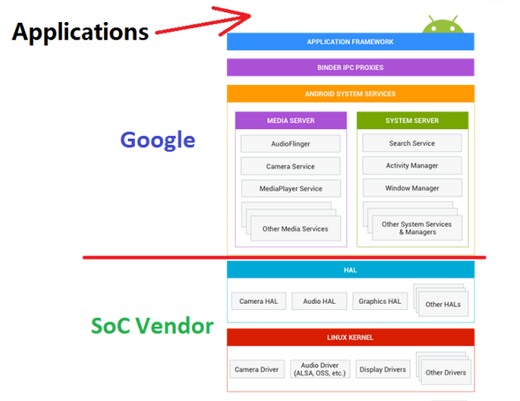

Before Android O, HAL is a .so library, opened by dlopen, and the library and framework are in the same process. as the picture shows:

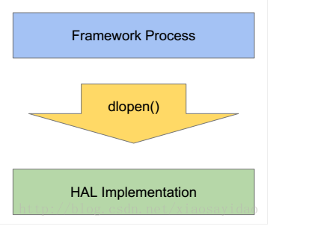

**Treble architecture :**

In order to upgrade the previous version of Android O to Android O, Android designed the Passthrough mode. After conversion, you can easily use the existing code without rewriting the relevant HAL. HIDL is divided into two modes: Passthrough and Binderized.

* Binderized: Google officially translated into a binding test HAL.
* Passthrough: Google officially translated into a straight-through HAL.

HIDL is a layer on top of the multiple HALs,and acts as a common interface between applictaion layer and device components.Now, to update the Android OS,only an update of the HIDL would be needed to make things work instead of having to rebuild all the HALS

HIDL separates the vendor implementation (device-specific, lower-level software written by silicon manufacturers) from the Android OS framework via a new vendor interface. Vendors or SOC makers build HALs once and place them in a **/vendor** partition on the device; the framework, in its own partition, can then be replaced with an [over-the-air (OTA) update](https://source.android.com/devices/tech/ota) without recompiling the HALs.

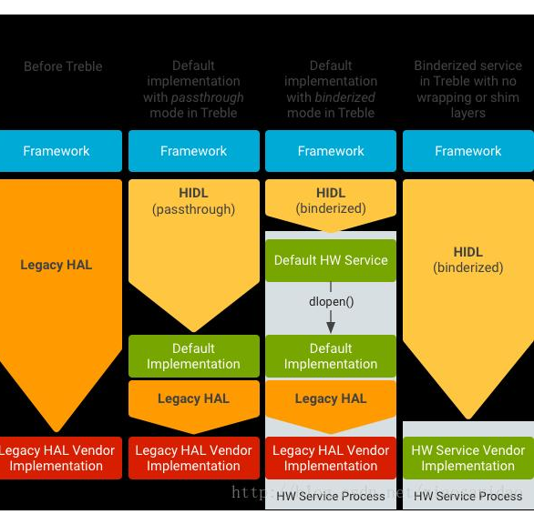

Under the new architecture, the framework and hal run in different processes, and all HALs are implemented using new HIDL technology.

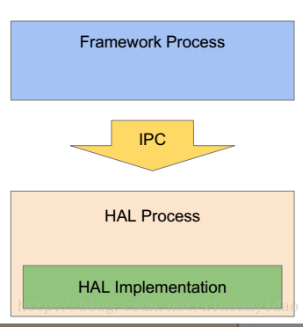

**HALs before Treble :**

**•** Before Treble HAL interfaces were defined as a bunch of C header files in hardware/libhardware folder. Each new version of Android meant new interface that HAL needed to support.

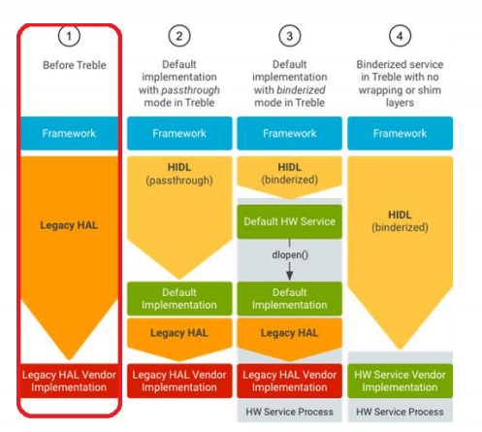

* Pass-through HALs have HIDL interface, but we call them directly from our process, not through Binder

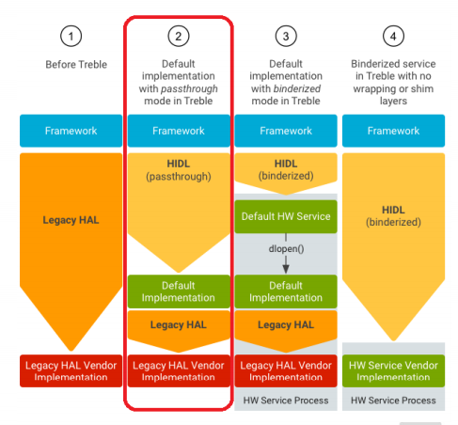

* Binderized HALs run in their own process and accessible only through Binder IPC calls
* Google craeted a wrapper for Legacy HALS.

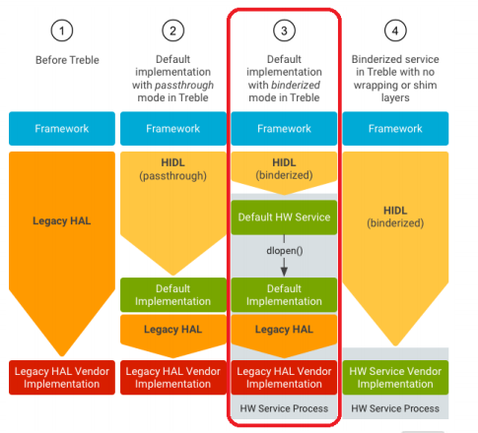

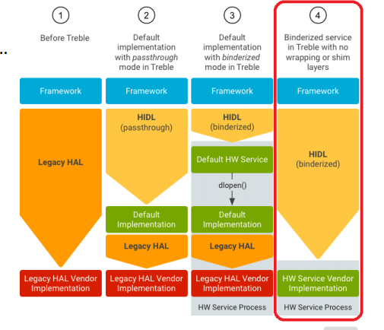

**Vendor Interface Object :**

• 4 things need to match for upgrade to be successful:

•HALs ( versions and interfaces)

•Kernel (version and configs)

• SE Policy (Security Policy versions)

• AVB ( Android Verified Boot) library version

